☀ ION GREEN – Solar EPC Solutions
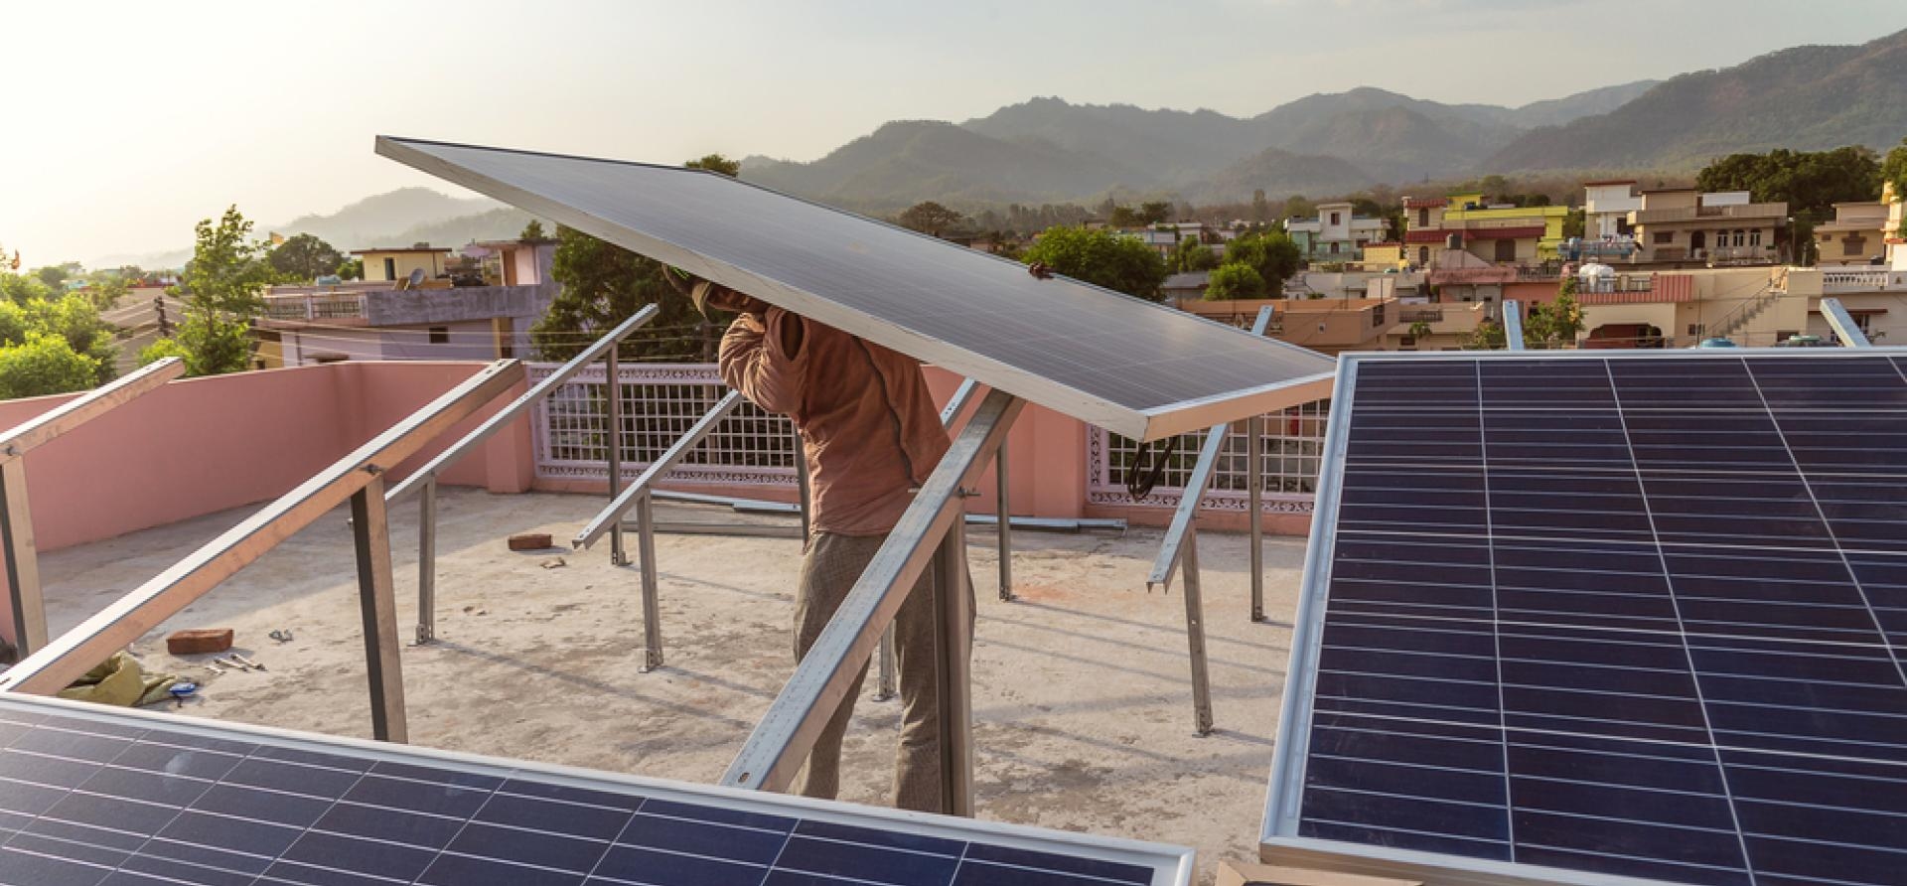
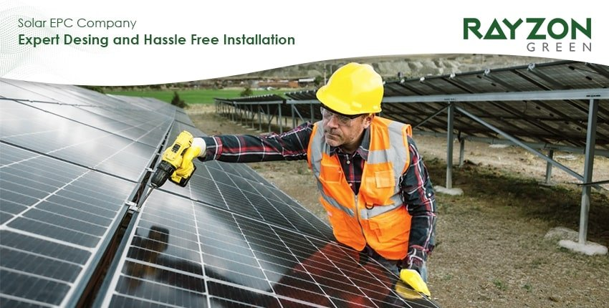
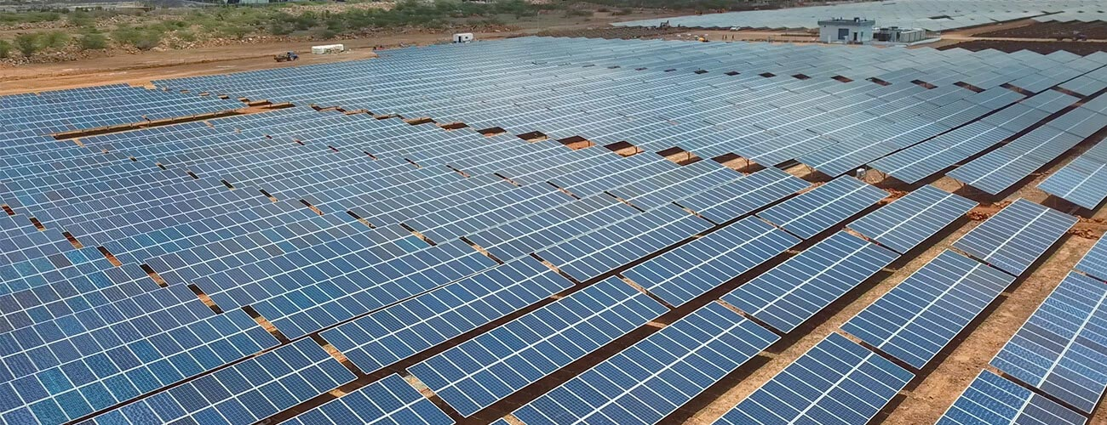
4

What We Offer
ION GREEN delivers end-to-end Solar EPC (Engineering, Procurement & Construction) solutions for Residential, Commercial, Industrial and Utility-scale projects.
We manage the entire project lifecycle — from concept to commissioning and long-term maintenance.

🔧 1️⃣ Engineering (Design & Planning)
We provide complete technical design and feasibility analysis:
- Site survey & shadow analysis
- Load analysis & energy consumption study
- System sizing (kW to MW scale)
- Electrical SLD (Single Line Diagram)
- Structural design & mounting layout
- Net metering & grid compliance support
- Hybrid solar + battery integration design
💡 For industrial clients, we design solar + BESS integration to reduce peak demand charges.

📦 2️⃣ Procurement (Quality Equipment Supply)
We source and supply:
- Tier-1 Solar Panels (Mono PERC / TOPCon)
- On-grid & Hybrid Inverters
- Mounting Structures (Rooftop / Ground Mounted)
- DC & AC Cabling
- LT Panels & Protection Systems
- Lightning Protection & Earthing
- Monitoring Systems
If integrated with storage:
- LFP Battery Packs (In-house ION GREEN manufacturing)
- Hybrid Inverters
- Energy Management Systems

🏗 3️⃣ Construction & Installation
- Structure fabrication & erection
- Module installation
- DC & AC wiring
- Inverter installation
- Net meter coordination
- Testing & commissioning
- Grid synchronization
We ensure:
✔ Safety compliance
✔ Electrical standards adherence
✔ Timely project delivery

🏢 Our Solar EPC Segments

🏠 Residential Solar Systems (3 kW – 10 kW)
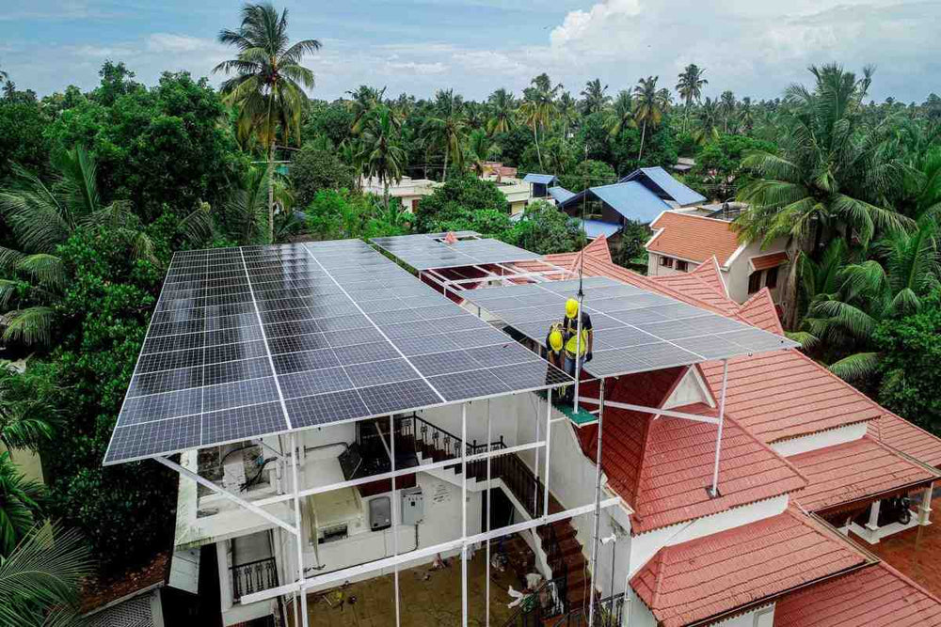
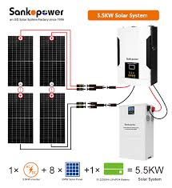
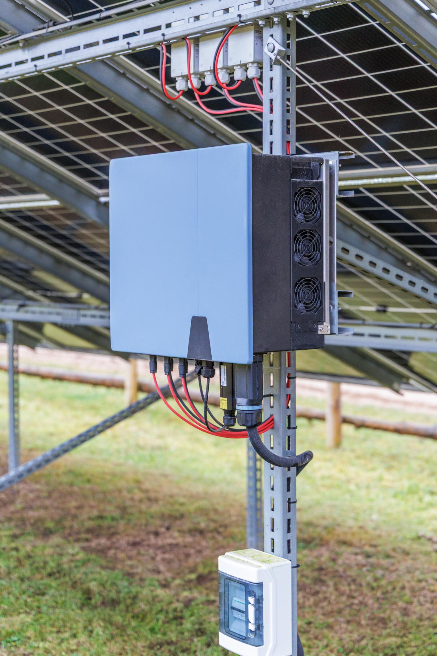
4
- Rooftop solar for homes
- Hybrid solar with battery backup
- Net metering support
- Smart monitoring via mobile app

🏬 Commercial & Industrial Solar (10 kW – 500 kW+)
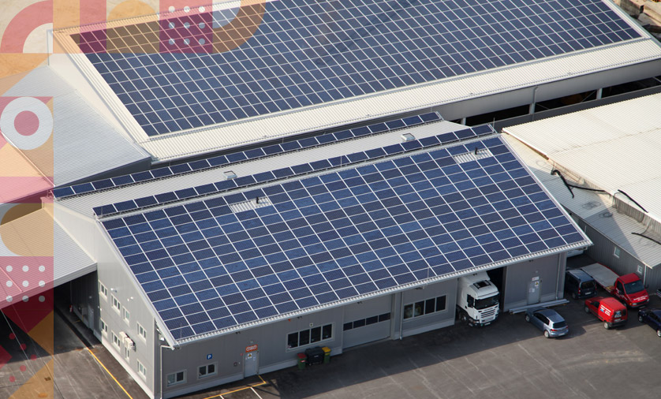
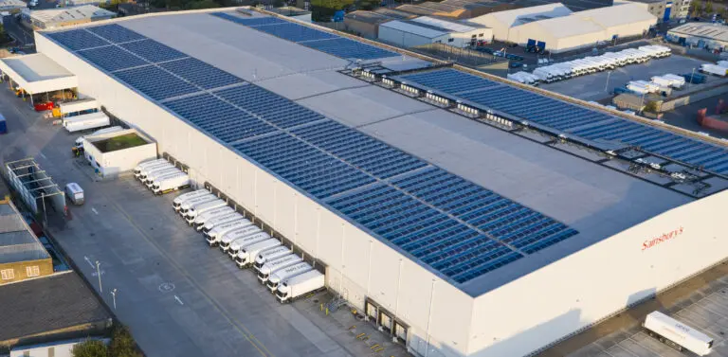
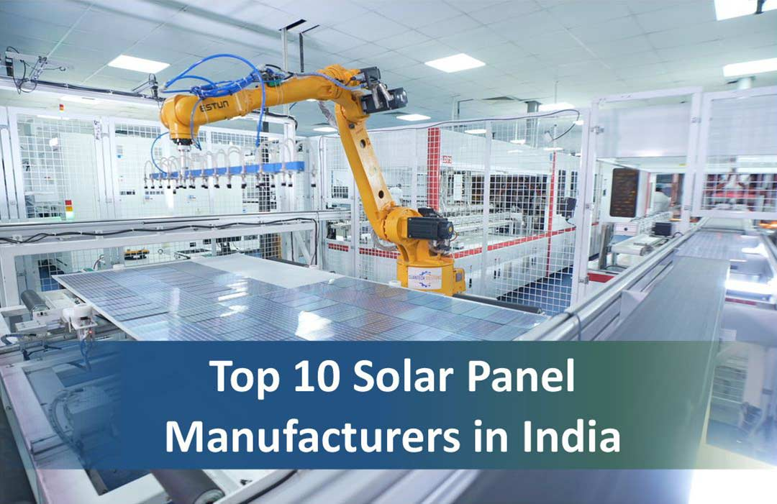
4
- Factory rooftop solar
- Office building solar
- Demand charge reduction systems
- Solar + DG + Battery hybrid solutions

🌾 Ground Mounted & Utility Solar (1 MW+)

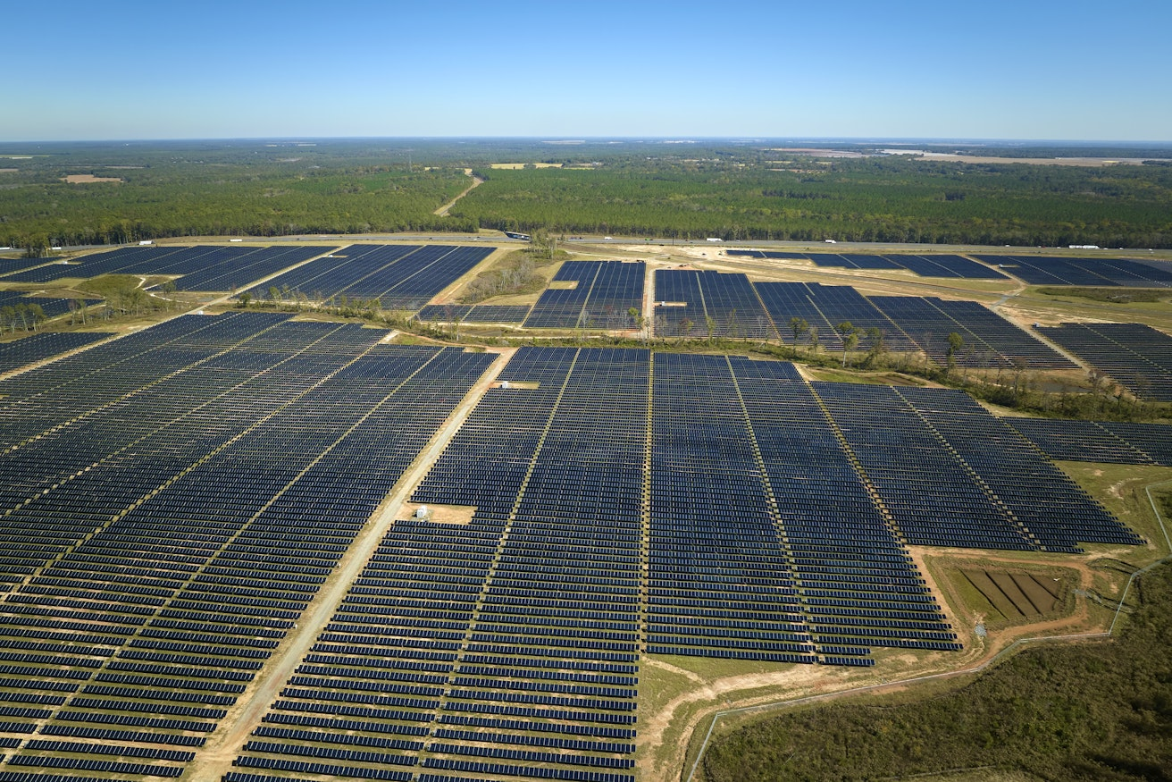
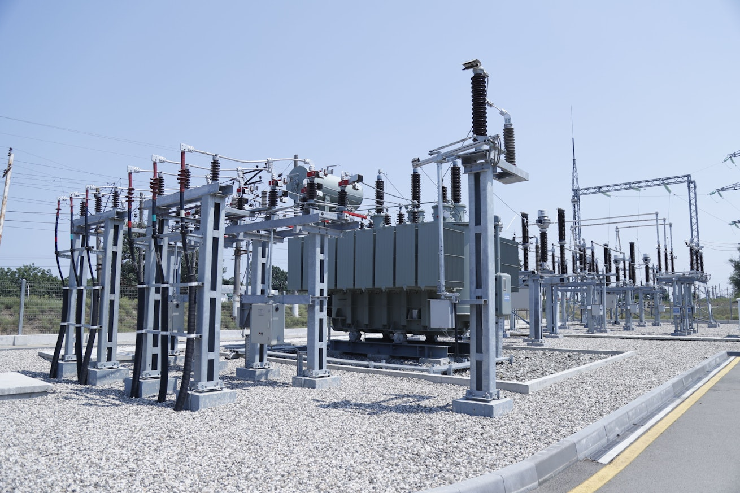
4
- Land assessment & feasibility
- PPA-based projects
- Open access solar
- Substation & grid integration

⚡ Advanced Solar + Storage Integration
This is where ION GREEN becomes different.
We offer:
- Solar + BESS (Peak shaving)
- Solar + UPS Backup
- Solar + EV Charging Integration
- Solar + Hydrogen-ready infrastructure (future scope)
This gives clients:
✔ Lower electricity bills
✔ Energy independence
✔ Backup power
✔ Carbon footprint reduction

📊 Project Models We Support
- CAPEX Model (Client investment)
- RESCO Model (Pay per unit)
- Turnkey EPC
- O&M Contracts
- Annual Maintenance (AMC)

🛠 After-Sales & O&M Services
- Performance monitoring
- Panel cleaning schedule
- Inverter health check
- Preventive maintenance
- 24/7 technical support

🎯 Why Choose ION GREEN for Solar EPC?
✔ Integrated Solar + Battery Expertise
✔ In-house LFP Battery Manufacturing
✔ Industrial Energy Optimization Capability
✔ UPS & Backup Integration
✔ Future-ready Hydrogen & EV Integration

